# Project Checkpoint 02: Entity Relationship Diagram

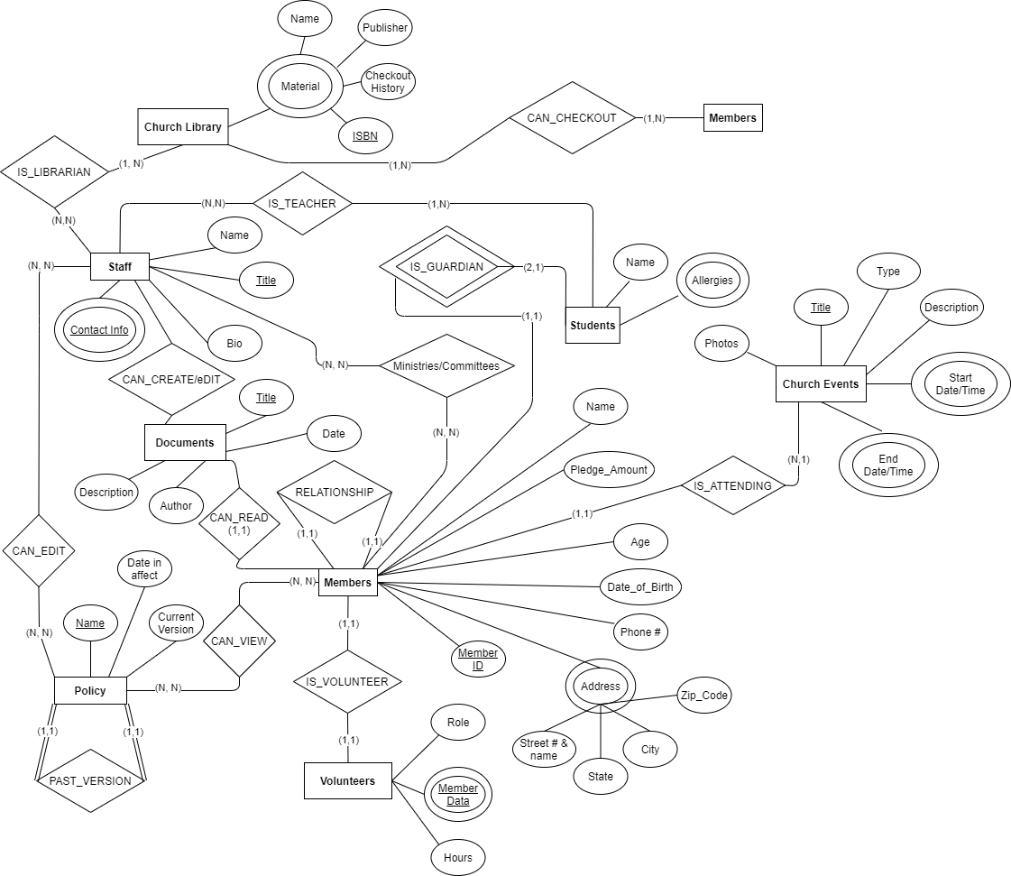

## Assumptions

* Not all redundant data was listed as attributes (EX: each Material attribute contains more data such as genre, date published, and description)
* Assumes Member can only checkout 1 book at a time
* Generalization of the Church Library (as that is a database in itself)